Orbital Shaker-Incubator—TOS20
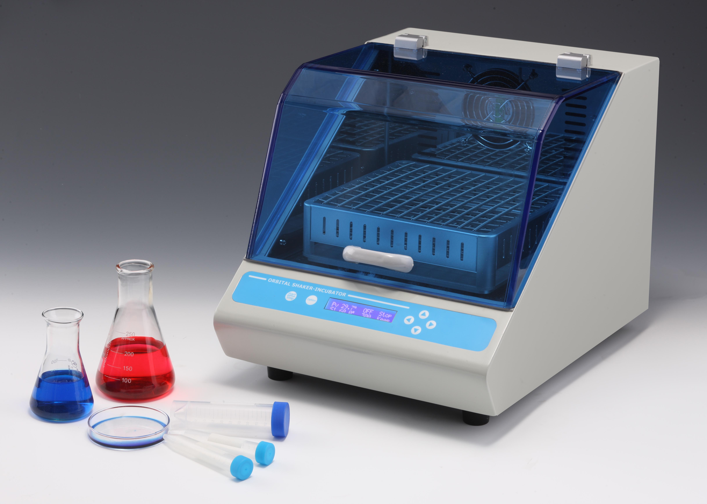
Description:
Orbital Shaker-Incubator is a compact bench–top Shaker–Incubator used for mixing of biological liquids as well as for incubation and cultivation of biological liquids according to the operator set program. Seven interchangeable platforms allow it mix and culture samples in flask, petri dish, tubes, Elisa plates, and etc. Built–in microprocessor thermo controller provides constant temperature control in the incubator chamber. It is extremely easy to operate, with very straightforward setup of temperature, speed and time.

Features:
- Instantly display operation information(time, temperature and speed) on
the LCD screen.
- Gentle and reliable shaking with direct brushless DC motor.
- Running safely –-heating and shaking will be automatically stopped once
the lid is open.
- Seven interchangeable platforms can be chosen for variety demands.
- Auto restart in case of power failure.
- Over-heating protection device is included.
- Built-in temperature calibration function.
- Compact, only 421mmx320mm(DXW)

Parameters:
Type  Parameter | MS100
Temperature setting range | 0°C ~60°C
Temperature control range | RT.+5°C ~60°C
Time range | 1min ~ 99h59min/∞
Temp. accuracy | ≤±0.5°C(@37°C)
Display accuracy | 0.1°C
Temp. uniformity | ≤±0.5°C(@37°C)
Shaking range | 50~300rpm
Orbit | 20mm
Platform dimension | 230x230mm
Internal chamber height | 182mm
Load capacity | 4.0kg
Heating time | ≤15min(from 25°C to 60°C)
Auto resume to run | Yes
Power | 350W
Voltage | AC220V/50-60HZ
Fuse | 250V 3A Ф5×20
Dimension(mm) | 421x320x338
Weight(kg) | 18.5

Optional Platforms
Type | Description
PF-1 | Platform with clamps for 5×250ml conical flask
PF-2 | Platform with clamps for 9×100ml conical flask
PF-3 | Platform with clamps for 10×50ml tube
PF-4 | Platform with clamps for 18×15ml tube
PF-5 | Platform with spring holder
PF-6 | Platform for 4pcs Elisa plates or deep-well plates
PF-7 | Flat platform for 5pcs petri dishes

